Performance Analysis and Optimization of CPU Usage on a MacBook

An Assignment submitted in partial fulfillment of the requirements for the degree of
Bachelor of Science
in
Computer Science

CS 3307: Operating System 2
Term 5 - 2026
University of The People

5th August, 2026

Performance Analysis and Optimization of CPU Usage on a MacBook
Introduction
Modern laptops, such as the MacBook, are designed to handle various workloads, including web browsing with multiple tabs, video editing, and running virtual machines. However, users sometimes notice system sluggishness when multitasking. This paper analyzes the performance of a MacBook under such conditions, focusing on CPU usage, and presents diagnostic and tuning strategies to improve system efficiency.
Analyzing CPU performance and identifying bottlenecks
The first step in addressing performance concerns is to analyze the system’s CPU performance and identify common bottlenecks. On macOS, the built-in top command is one of the most effective tools for real-time monitoring of system activity. By executing top -o cpu, processes are sorted by CPU usage, revealing which applications are consuming the most resources (see Example Output below).
Sample Output:
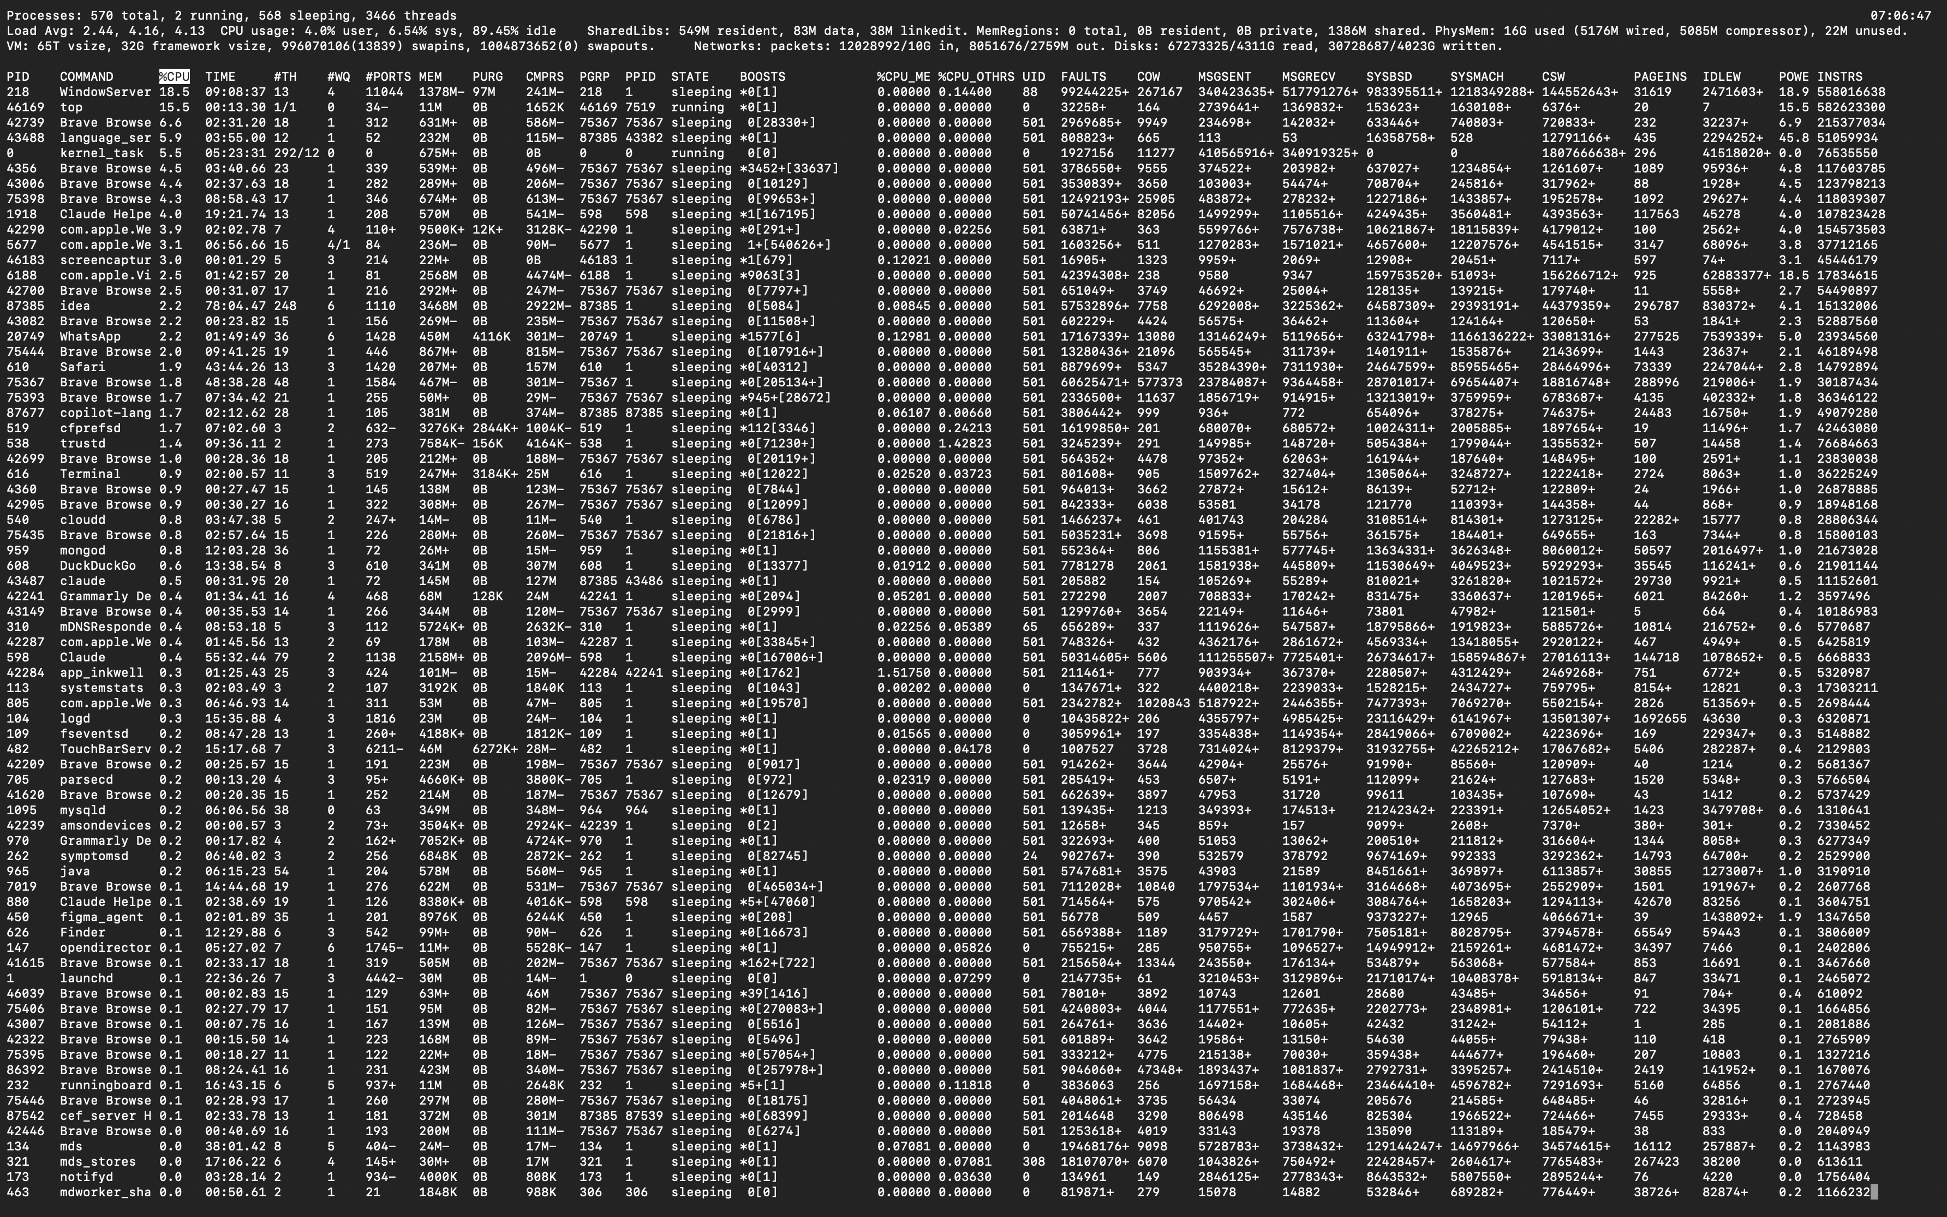
These results indicate that the system was mostly idle (approximately 89.4%), with the highest CPU usage coming from WindowServer (18.5%), VTDecoderXPCService (10.1%), and Brave Browser (8.6%). WindowServer is responsible for macOS graphical user interface management, VTDecoderXPCService handles video decoding, and Brave Browser’s usage likely results from multiple active tabs or multimedia content. These findings suggest that, during typical desktop use, high CPU utilization is driven by graphical and browser-related processes.
Memory analysis using commands such as vm_stat showed no excessive memory pressure. With 16 GB of installed RAM and approximately 5.5 GB actively used, it is unlikely that memory limitations are causing CPU bottlenecks.
Monitoring CPU performance with scripting
To monitor CPU performance systematically, a Bash script can record CPU usage every minute for five minutes. Below is an example script suitable for macOS and Linux environments:
#!/bin/bash
# Output file
OUTPUT_FILE="cpu_usage_log.txt"
# Write header
echo "CPU Usage Monitoring Log" > "$OUTPUT_FILE"
echo "Started: $(date)" >> "$OUTPUT_FILE"
echo "=========================================" >> "$OUTPUT_FILE"
# Monitor CPU usage every minute for 5 minutes
for i in {1..5}
do
echo "Sample $i - $(date)" >> "$OUTPUT_FILE"
# Display CPU usage summary
top -l 1 | grep "CPU usage" >> "$OUTPUT_FILE"
echo "-----------------------------------------" >> "$OUTPUT_FILE"
# Wait one minute before the next sample
if [ $i -lt 5 ]; then
sleep 60
fi
done
echo "Monitoring completed."
echo "Results saved to $OUTPUT_FILE"

Sample content from the resulting cpu_usage_log.txt file:
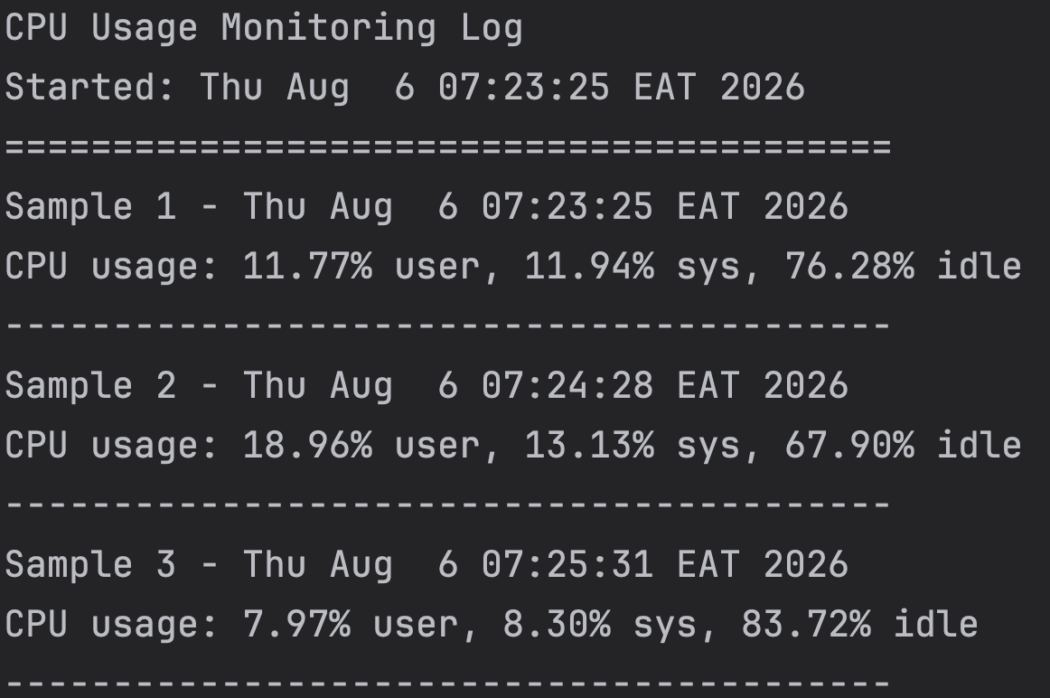
This log allows users to observe CPU utilization trends and identify periods of high load.
Troubleshooting High CPU Usage and Proposing Scheduling Strategies If the monitoring data or user experience suggests persistent high CPU usage, a systematic troubleshooting workflow is recommended:
- Identify high-CPU processes using top -o cpu or the ps command.
- Check for excessive memory pressure with vm_stat.
- Collect detailed CPU information with sudo powermetrics --samplers cpu_power.
- Analyze the data for bottlenecks, such as low idle CPU percentages or one process dominating CPU usage.
For example, if WindowServer consistently uses a large portion of the CPU, reducing the number of open windows or disabling graphical effects may help. If a web browser consumes excessive CPU, closing unnecessary tabs or extensions can reclaim resources.
Implementing performance tuning strategies for CPU Scheduling
CPU scheduling determines how processes share processor time. On Unix-like systems, the default scheduler is usually the Completely Fair Scheduler (CFS), which balances processes to optimize responsiveness. However, users can influence process priority using the nice and renice commands. Lowering the priority of resource-hungry background tasks can make interactive applications more responsive.
Step-by-Step Resolution Strategy
- Use top -o cpu and ps to identify processes with high CPU usage.
- For non-essential or background processes using excessive CPU, lower their priority:
  - Run sudo renice +10 [PID] (replace [PID] with the process ID).
- Close unnecessary applications and browser tabs.
- Reduce graphical effects and animations via System Preferences.
- Monitor CPU usage again to verify improvement.
- If the problem persists, consider restarting the system or updating software to benefit from performance optimizations and bug fixes.
Conclusion
By combining built-in diagnostic tools, automated monitoring scripts, and basic scheduling controls, users can effectively analyze and optimize CPU performance on a MacBook. The data-driven approach outlined in this essay ensures that interventions are targeted, measurable, and rooted in real-world usage. These strategies are broadly applicable to both macOS and other operating systems, promoting efficient system operation for diverse workloads.

